

Keeping in Touch at SMUMCHH
Week of April 20, 2025

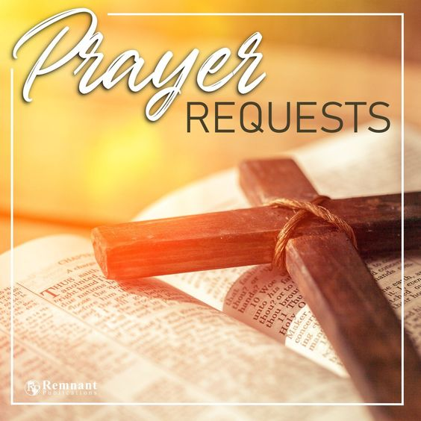
Prayers for our Church Family:
Frank (son of Ruth Barnes) had an accident while riding his
E-bike. He is currently in the hospital after having surgery on his hip. He also had a rod inserted into his leg. He is in serious condition and will be hospitalized for quite sometime.
Warren Howe (Larry Howe’s Brother) was riding his E-Bike Saturday evening and got hit by a car (a hit and run driver). Warren is in the hospital with a fractured rib,
elbow and vertebrae in his back.

Prayers out into our World:
Continued prayers to all those in the United States who are affected in many ways, by all of the recent and current severe weather conditions – wildfires, tornados, winds, flooding, and snow and rain storms, to include the earthquakes. Condolences and prayers to those who have lost their loved ones and friends in these storms. Thanks to those who are helping with the recovery efforts.
Keep those in Myanmar (Burma) surrounded by prayers following the devastating 7.7 earthquake.
Prayers for resolutions and peace for each and every conflict happening within
the U.S.A.
Prayers for peace and resolutions for all the World’s conflicts!

Continued prayers for our Members, Family, and Friends:
Terry Feulner (and Joy too), Donna Lilly, Ruth Feick, Jean Logan,
Doris Sachs, Dorothy Tarvin, Chris Kozak (son of Rich and Denise Kozak), Diane Crawford (daughter of Shirley Butler), Jeff Graves (son of Joe and Patty Graves), Ted Williams (and Betty as well).



8:00 a.m. Informal Service
10:00 a.m. Traditional Worship

Coffee Fellowship Hosts and Hostesses

April 20 (Easter) Rodney Kurimoto
April 27 The Hewko Family
May 4 Donna and Todd Peterson
May 11 (Mother’s Day) Bob and Diane Hernandez
May 18 Alice Cheng and Family
May 25 Shirley Butler and Dorothy Persinger
June 1
June 8
If you would like to host our Coffee Fellowship Time after Worship on any Sunday, please contact or see Carol Rogers.


Liturgists for our 10:00am Worship Services are urgently needed. If you would like to be a Liturgist, please give Olga Baker a call or see her after church service.

Those whose names are printed in red, have a special celebration this coming week:

April Birthdays April 22 Lucille Householder

April Wedding Anniversary April 27 Pastor David and Mary Choi

May Birthdays May 1 Linda Hall
May 2 Eleanor Brown
May 3 Donna Matsumura
Howard King
May Anniversary May 3 Larry & Judy Vroman



“WARMER MONTHS” OUTREACH PROJECT - HYGIENE KITS !!!


In the early years of housing the homeless here at St. Matthew’s UMC, we would bring in a “shower wagon” to our campus giving the homeless an opportunity to shower. We also gave those wanting to shower a bag containing hygiene items to use, as well as to keep when they were finished showering.

I've been informed of the need of hygiene items to be provided at the Annual Reach Out Program in Whittier Narrows Park where portable “shower wagons” are brought in and items for personal hygiene kits are distributed.

As we journey in Spring and Summer, LET'S CONSIDER A NEW PROJECT –
“HYGIENE KITS”!

Suggested items needed for the kits (note: Dollar Tree Stores and those “travel size items” at Walmart and Target and some Drug Stores are a great place to purchase any of these items) are:
small bottles of shampoo, bath soap (bars or liquid),
tooth paste, toothbrush, teeth floss or floss pics,
comb, deodorant, band aids, q-tips, small bottle of body powder,
body lotion, or sunscreen, washcloths and/or towels are welcome too.
*Please – NO razors or disposable razors, or any type of scissors.

Please bring items to Church on Sundays, or . . . drop items by the office during the week. This will be an ongoing project for a few months. Let’s spread our Lord’s love and care! Any questions, please see Morgan Matthews after Worship or call the Church Office.
-Morgan Matthews, Outreach Coordinator, St. Matthew’s UMC

Pastor David continues to offer Free Music Lessons to our
community. Learn how to play the keyboard, guitar or drums. Call
the church office at 626-333-6656 or email the office at
smumchh@gmail.com for more information.
Easter Lily Plants
The following Members of our Congregation present
the beautiful Lily Plants in our Sanctuary for Easter
Morning. All the Lilies are given in memory of or
in honor of loved ones and friends.

Shirley Aney in memory of beloved husband, Tom Aney, and Timothy Aney,
beloved son.
Olga Baker and daughters, Jackie, Kelly, and Tracy, and their families, in loving memory of Hillis Baker.
Ruth Barnes in memory of my mother and father, Esther and Richard Jacoby, and in memory of my husband, Harold Barnes.
Wes Brown in memory of Diane Brown; and in memory of the Brown and
Bulher Families.
Shirley Butler in honor of my family.
Dick and Diane Cline in memory of Ted and Irene Phillips and Ralph and
Elizabeth Cline; and in honor of our daughters, Leslie, Stephanie, and Tracy and families.
David and Sheila Crain in honor of our grandchildren - Joshua, Matthew, Nathan, Kenna, and Alexa.
Kathy Farley with praise and gratitude to God for new insights, new friends, and the blessings of this past year.
Margaret Gow in memory of Ronald Gow and Sharon Elaine Gow; in honor of Christine Ernst and grandchildren and Lesley O’Leary and grandchildren.
Bob and Diane Hernandez in memory of our parents, Frank and Shirley Bell
and Lydia Pio.
Rick & Pat Kunishima in memory Richard Sr. and Chiyo Kunishima, and brother, Randy Kunishima, Robert and Aldyth Lay, and brother, John Lay.
Rodney Kurimoto in memory of friends and family.
Jean Logan in loving memory of Gene, Darren and Megan Logan.
Jerry and Marilyn Lutjens in memory of Don and Carrie Jackson and
Robert and Evelyn Lutjens.
Donna and Kevin Matsumura in memory of Frank and Shirley Bell (Mom and Dad), Grandparents, and Mary Matsumura (Grandma); and in honor of my son,
Peter Matsumura, whose is in the Air Force.
Dorothy Persinger in memory of Cynthia Sullivan.
(continued next page)
The Robles Family in memory of Rafael Arredondo (Sam’s Dad) and
Juan and Rosa Robles (Rosa’s parents).
Carol Rogers in memory of Ian Rogers and Helen and Darl Bowser; and in honor
of the Shalom Sisters.

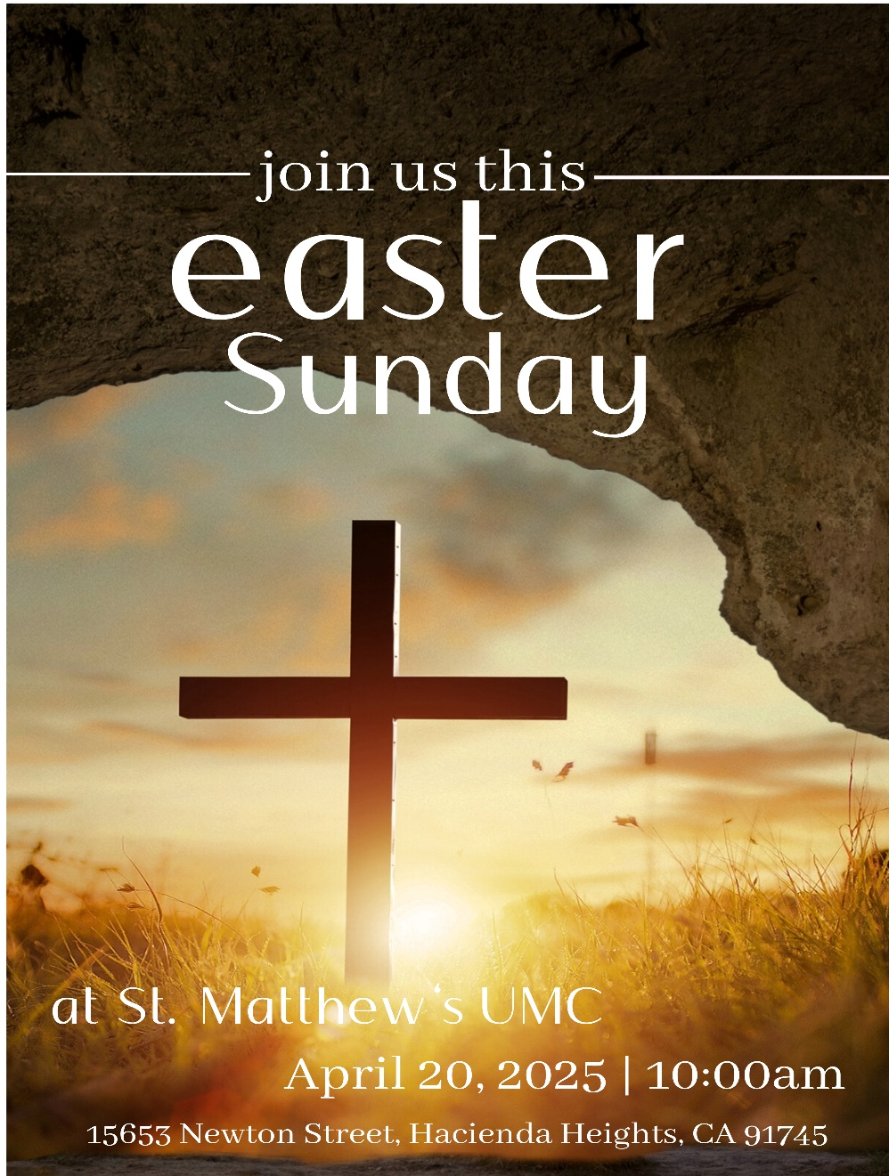

YES! WE WILL HAVE OUR
EASTER FLOWER CROSS
on the lawn on Easter Sunday
morning. So please bring your
favorite beautiful flowers to
church on Easter morning and
place on the cross in
celebration of the
Risen Christ!!

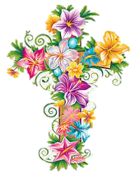



St. Mathew’s United Methodist Church
15653 Newton Street, Hacienda Heights, CA 91745
626-333-6656 smumchh@gmail.com www.stmattsumc.com

